GEOGRAPHY EXAMINATION

November/December 2022

**2 hours**

**Uganda Certificate of Education**

**Geography Examination**

**PAPER 1**

**2 hours**

**INSTRUCTIONS TO CANDIDATES:**

1. This paper consists of **Two** sections: **A** and **B**
2. Write answers in the spaces provided.
3. Do not write in the margin to the right. The examiner will use this space to mark your work.
4. The invigilator will tell you when you have 10 minutes to end of examination.
5. The marks for each section are shown in brackets; use this to guide you on how much time to spend on each question.
6. Use a calculator and mathematical instruments where applicable.

**ADVICE**

1. Read the whole question before answering – especially if there is more than one part to the question.
2. If you finish early, check your answers.

**SECTION A: Short response questions (40 MARKS)**

Answer **all** questions in this section

**Section B: Skill based questions (60 MARKS)**

Answer **all** questions in this section

**SECTION A:** **SHORT RESPONSE QUESTIONS (40 MARKS)**

Answer **all** questions in this Section.

**Question 1**

Study Fig. 1 showing the location of Bangkok and Dar es Salaam using latitude and longitude and the question that follows.

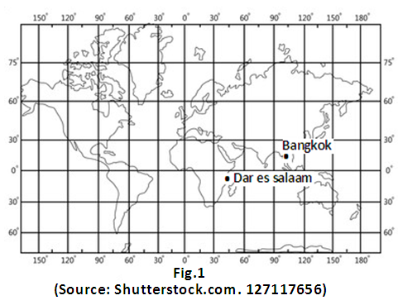

(a) Dar es Salaam lies 400 east of the Prime Meridian while Bangkok City lies 1000 east of the Meridian.

If it is 7:00 am (GMT) at Dar es Salaam, what time is it at Bangkok?

--- -----------------------------------------------------------------------------------------------------------------

---------------------------------------------------------------------------------------------------------------------

---------------------------------------------------------------------------------------------------------------------

(**2**)

(b) Explain two ways in which the rotation of the earth influences the ways of life of the people in your community.

---------------------------------------------------------------------------------------------------------------------

---------------------------------------------------------------------------------------------------------------------

---------------------------------------------------------------------------------------------------------------------

---------------------------------------------------------------------------------------------------------------------

---------------------------------------------------------------------------------------------------------------------

---------------------------------------------------------------------------------------------------------------------

(**2**)

**Question 2**

Study Fig.2 which shows a mine in Eastern Uganda and answer the following questions.

a). Identify the method of mining being used in the area shown in Fig. 2.

---------------------------------------------------------------------------------------------------------------------

(**1**)

b). Describe two environmental problems caused by mining in the area shown in Fig.2.

---------------------------------------------------------------------------------------------------------------------

---------------------------------------------------------------------------------------------------------------------

---------------------------------------------------------------------------------------------------------------------

---------------------------------------------------------------------------------------------------------------------

--------------------------------------------------------------------------------------------------------------------- (**3**)

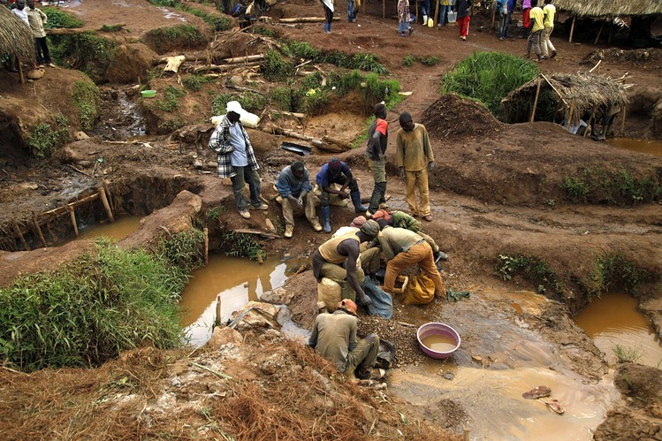

Fig. 2

**Question 3**

East African countries have seen a major increase in tourist arrivals for both business and leisure purposes.

Explain **two** reasons for the rapid development of the tourism industry in East Africa.

--------------------------------------------------------------------------------------------------------------------

---------------------------------------------------------------------------------------------------------------------

---------------------------------------------------------------------------------------------------------------------

---------------------------------------------------------------------------------------------------------------------

---------------------------------------------------------------------------------------------------------------------

---------------------------------------------------------------------------------------------------------------------

------------------------------------------------------------------------------------------------------------------- (**4)**

**Question 4**

In the past 20 years Uganda has lost 12% of its forest cover.

Explain **two** problems which have resulted from the great reduction in the country’s forest cover.

---------------------------------------------------------------------------------------------------------------------

---------------------------------------------------------------------------------------------------------------------

---------------------------------------------------------------------------------------------------------------------

---------------------------------------------------------------------------------------------------------------------

--------------------------------------------------------------------------------------------------------------------

---------------------------------------------------------------------------------------------------------------------

---------------------------------------------------------------------------------------------------------------------

--------------------------------------------------------------------------------------------------------------------- (**4**)

**Question 5**

Study Fig. 3 and use it to answer the questions which follow.

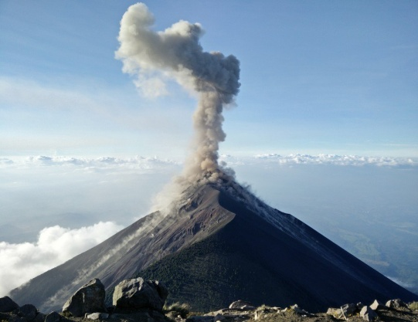

Fig. 3

(Source: Rick ride horses, 2011)

a). What process is taking place in Fig. 3?

---------------------------------------------------------------------------------------------------------------------

(**1**)

b). Suggest two problems which may be caused by the process you have identified in (a) above.

1. -------------------------------------------------------------------------------------------------------------

------------------------------------------------------------------------------------------------------------

------------------------------------------------------------------------------------------------------------

1. -------------------------------------------------------------------------------------------------------------

------------------------------------------------------------------------------------------------------------

------------------------------------------------------------------------------------------------------------

(**3**)

**Question 6**

Choose a local manufacturing or processing industry you have studied. Explain **two** ways in which it benefits the local community in the area.

Name of industry----------------------------------------------------------------------------- (**1**)

Benefits to the local community:

------------------------------------------------------------------------------------------------------------------------------------------------------------------------------------------------------------------------------------------

---------------------------------------------------------------------------------------------------------------------

---------------------------------------------------------------------------------------------------------------------

---------------------------------------------------------------------------------------------------------------------

---------------------------------------------------------------------------------------------------------------------

---------------------------------------------------------------------------------------------------------------------

-----------------------------------------------------------------------------------------------------------------------------

(**3**)

**Question 7**

The use of internet and mobile phones has improved people’s lives. However, according to the recent crime police report of 2020 the use of internet and mobile phones has resulted in loss of 15 billion shillings.

Explain **two** ways in which the use of internet and mobile phones has affected people in your community.

-------------------------------------------------------------------------------------------------------------------------------------------------------------------------------------------------------------------------------------------------------------------------------------------------------------------------------------------------------------------------------------------------------------------------------------------------------------------------------------------------------------------------------------------------------------------------------------------------------------------------------------------------------------------------------------------------------------------------------------------------------------------------------------------------------------------------------------------------------------------------------------------------------------------------------------------------------------------------------------------------------------------------------------------------------------------------------------------------------------------------------------------------------------------------------------------------------------------------------------------------------------------------------- (**4**)

**Question 8**

Explain any **two** factors responsible for the limited trade between East African countries.

------------------------------------------------------------------------------------------------------------------------------

-------------------------------------------------------------------------------------------------------------------------------

-------------------------------------------------------------------------------------------------------------------------------

-------------------------------------------------------------------------------------------------------------------------------

-------------------------------------------------------------------------------------------------------------------------------

-------------------------------------------------------------------------------------------------------------------------------

-------------------------------------------------------------------------------------------------------------------------------

-------------------------------------------------------------------------------------------------------------------------------

-------------------------------------------------------------------------------------------------------------------------------

-------------------------------------------------------------------------------------------------------------------------------

------------------------------------------------------------------------------------------------------------------------ (**4**)

**Question 9**

Study Fig. 4 which shows a river flood plain and answer the questions 9 and 10.

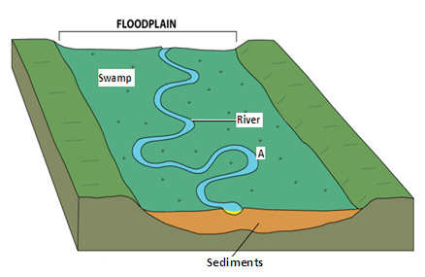

Fig. 4

a). Explain how an ox-bow lake may form at the place marked **A**.

-------------------------------------------------------------------------------------------------------------------------------

-------------------------------------------------------------------------------------------------------------------------------

-------------------------------------------------------------------------------------------------------------------------------

-------------------------------------------------------------------------------------------------------------------------------

-------------------------------------------------------------------------------------------------------------------------------

-------------------------------------------------------------------------------------------------------------------------------

-------------------------------------------------------------------------------------------------------------------------------

-------------------------------------------------------------------------------------------------------------------------------

-------------------------------------------------------------------------------------------------------------------------------

-------------------------------------------------------------------------------------------------------------------------------

-------------------------------------------------------------------------------------------------------------------------------

(**4**)

**Question 10**

Imagine your family migrated and settled on the flood plain shown in Fig. 4.

Explain **two** disadvantages which would be associated with your new area of residence.

-------------------------------------------------------------------------------------------------------------------------------

-------------------------------------------------------------------------------------------------------------------------------

-------------------------------------------------------------------------------------------------------------------------------

-------------------------------------------------------------------------------------------------------------------------------

-------------------------------------------------------------------------------------------------------------------------------

-------------------------------------------------------------------------------------------------------------------------------

-------------------------------------------------------------------------------------------------------------------------------

-------------------------------------------------------------------------------------------------------------------------------

-------------------------------------------------------------------------------------------------------------------------------

-------------------------------------------------------------------------------------------------------------------------------

(**4**)

**SECTION B: SKILL- BASED SHORT ANSWER QUESTIONS (60 MARKS)**

*Answer* **all** *questions in this section*

**Question 11**

Study the (**UGANDA**) map extract of Kakuto (***insert***) provided and answers the following questions:

a). What is the scale of the map? -------------------------------------------------------------- (**1**)

b). State the four- figure grid reference of the trigonometrical station pillar on Kyesimbyehill peak.

--------------------------------------------------------------------------------------------------- (**1**)

c). Calculate the approximate area of the airfield run way at Lukoma.

-------------------------------------------------------------------------------------------------------------------------------

-------------------------------------------------------------------------------------------------------------------------------

-------------------------------------------------------------------------------------------------------------------------------

-------------------------------------------------------------------------------------------------------------------------------

(**2**)

d). Give **two** reasons why the south eastern part of Kakuto Sub County is a good place for plantation farming.

-------------------------------------------------------------------------------------------------------------------------------

-------------------------------------------------------------------------------------------------------------------------------

-------------------------------------------------------------------------------------------------------------------------------

-------------------------------------------------------------------------------------------------------------------------------

-------------------------------------------------------------------------------------------------------------------------------

-------------------------------------------------------------------------------------------------------------------------------

-------------------------------------------------------------------------------------------------------------------------------

-------------------------------------------------------------------------------------------------------------------------------

-------------------------------------------------------------------------------------------------------------------------------

**(4)**

e). Describe the relief of the area shown on the map.

--------------------------------------------------------------------------------------------------------------------------

--------------------------------------------------------------------------------------------------------------------------

--------------------------------------------------------------------------------------------------------------------------

--------------------------------------------------------------------------------------------------------------------------

--------------------------------------------------------------------------------------------------------------------------

---------------------------------------------------------------------------------------------------------------------------------------------------------------------------------------------------------------------------------------------------------------------------------------------------------------------------------------------------------------------------------------------------------------------------------------------------------------------------------

(**4**)

f). In the frame provided below, draw a sketch map of Kakuto between grid references 2091, 3091, 2000 and 3000 and on it mark and name:

1. the loose surface road, (**1**)
2. a river, (**1**)
3. a hill, (**1**)
4. the plantation, (**1)**

|  |
| --- |
|  |
| **Key** |

g). Suppose the local government of Kyotera district has given you a contract to lay a water pipe line from River Byembago (grid reference 239947) to the Ministry of Works Station (grid reference 279018).

Estimate the:

(i). Length of the pipe line if you are to construct it following the alignment of the existing road.

---------------------------------------------------------------------------------------------------------------------

---------------------------------------------------------------------------------------------------------------------

---------------------------------------------------------------------------------------------------------------------

(**2**)

(ii).The total cost of piping if each kilometer of the pipeline costs 2 million Uganda shillings.

---------------------------------------------------------------------------------------------------------------------

---------------------------------------------------------------------------------------------------------------------

---------------------------------------------------------------------------------------------------------------------

---------------------------------------------------------------------------------------------------------------------

**(2)**

**Question 12**

Look at Fig.5 below, a photograph taken from an area in East Africa and answer the questions that follow.

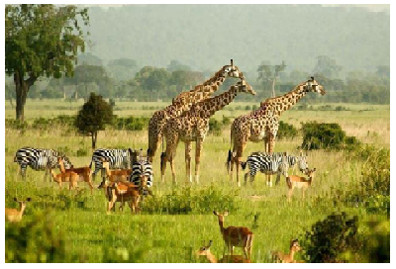

**Fig.5**

a). Identify the type of:

1. Photograph Figure 5 is. ----------------------------------------------------------------------------- (**1**)
2. Relief shown in the photograph ------------------------------------------------------------------- (**1**)
3. Vegetation in the foreground ----------------------------------------------------------------------- (**1**)
4. Vegetation in the background of the photograph. --------------------------------------------- (**1**)

(v) Land use shown in the foreground of the photograph. --------------------------------------- (**1**)

b). Suggest **two** ways in which the area shown in the photograph can be improved so that it can attract tourists.

--------------------------------------------------------------------------------------------------------------------------

---------------------------------------------------------------------------------------------------------------------------

---------------------------------------------------------------------------------------------------------------------------

---------------------------------------------------------------------------------------------------------------------------

----------------------------------------------------------------------------------------------------------------------------

-----------------------------------------------------------------------------------------------------------------------------

-----------------------------------------------------------------------------------------------------------------------------

------------------------------------------------------------------------------------------------------------------------------

(**4**)

c). Explain **three** likely benefits tourism might bring to the local community in the area where the photograph was taken.

-------------------------------------------------------------------------------------------------------------------------------

-------------------------------------------------------------------------------------------------------------------------------

-------------------------------------------------------------------------------------------------------------------------------

-------------------------------------------------------------------------------------------------------------------------------

-------------------------------------------------------------------------------------------------------------------------------

-------------------------------------------------------------------------------------------------------------------------------

-------------------------------------------------------------------------------------------------------------------------------

-------------------------------------------------------------------------------------------------------------------------------

(**6**)

d). Select an area of your choice, identify the physical and human tourist attractions.

Area: -------------------------------------------------------------------------------------------------------------------

Tourist attractions:

-------------------------------------------------------------------------------------------------------------------------------

-------------------------------------------------------------------------------------------------------------------------------

-------------------------------------------------------------------------------------------------------------------------------

(5)

**Question 13**

Study Fig.6 which shows the Demographic Transition Model and answer the questions that follow.

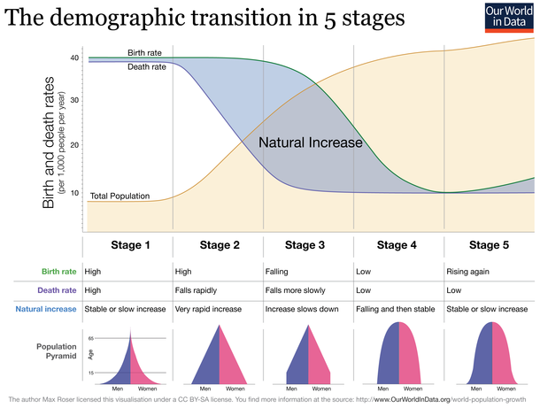

**Fig. 6** (Source: Wikpedia)

1. What can happen to a country if its death rate rises higher than the birth rate?

---------------------------------------------------------------------------------------------------------------------

---------------------------------------------------------------------------------------------------------------------

(**1**)

1. In which stage of the Demographic Transition Model are both birth rates and death rates high?

----------------------------------------------------------------------------------------------------------------

(**1**)

1. Give **four** possible reasons why birth rates have fallen by the time a country reaches Stage 4 of the model.

--------------------------------------------------------------------------------------------------------------------------

--------------------------------------------------------------------------------------------------------------------------

--------------------------------------------------------------------------------------------------------------------------

--------------------------------------------------------------------------------------------------------------------------

--------------------------------------------------------------------------------------------------------------------------

(**8**)

(d) **I**dentify the stage of the Demographic Transition Model in which Uganda is.

Give reasons to support your answer.

Stage ------------------------------------------------------------------------------------------------- **(2)**

Reasons

-------------------------------------------------------------------------------------------------------------------------------

-------------------------------------------------------------------------------------------------------------------------------

-------------------------------------------------------------------------------------------------------------------------------

-------------------------------------------------------------------------------------------------------------------------------

-------------------------------------------------------------------------------------------------------------------------------

---------------------------------------------------------------------------------------------------------------------

(**8**)

**END**

**UCE**

Uganda Certificate of Education

-----------------------------------------------------------------------------------------------

Geography Sample Assessment

**Paper 1**

-----------------------------------------------------------------------------------------------

## MARKING GUIDE

**General Marking Guidelines**

**Introduction**

This marking guide is intended to ensure that UCE examination is marked consistently and fairly. The scheme provides examiners with an indication of the nature of candidates’ responses likely to be worth of credit. It also sets out the criteria which the examiners should follow while allocating marks to candidates’ responses. The marking scheme should be read in conjunction with these general marking guide lines.

**Assessment objectives**

Below are the assessment objectives for UCE Geography.

Candidates should demonstrate that they are able to:

* Recall, select and communicate their knowledge and understanding of places, environments and concepts (AO1);
* Apply their knowledge and understanding in both familiar and unfamiliar contexts (AO2);
* Select and use a variety of skills, techniques and equipment to investigate, analyse and evaluate tasks and issues (AO3);
* Use their knowledge and understanding to form personal opinions about, and demonstrate appreciation of situations, issues and problems (AO4).

**Quality of candidates, responses**

In marking candidates’ scripts, examiners should be looking for a quality of response reflecting the level of maturity which may reasonably be expected of a 16- or 17- year old, which is the age at which the majority of the candidates sit their end of Lower secondary education cycle examination.

**Flexibility on marking**

This marking scheme is not intended to be prescriptive. It does not cover all the responses which candidates may produce. In the event of unexpected answers, examiners are expected to use their professional judgment to assess the validity of responses. If an answer is particularly problematic, then examiners should seek the guidance of the Chief Examiner.

**Positive marking**

Examiners are expected and encouraged to be positive while judging candidates’ work. They should give appropriate credit for what candidates **know**, **understand**, **can do** and **opinions they hold about a situation** rather than penalise them (candidates) for errors or omissions. Examiners should make use of the whole of the available mark range for any particular question and be prepared to award full marks for a response which is as good as might reasonably be expected of a 16- or 17-year old candidate.

**Awarding Zero marks**

Marks should only be awarded for valid responses and no mark should be awarded for a response which is completely incorrect or inappropriate.

**Awarding types of response**

Items or questions which require very short answers/responses should be marked on **a point for point basis** where marks are awarded for each valid piece of information provided by the candidate.

Questions or tasks which require candidates to respond in a more detailed form should be marked on the basis of **levels of response** which take into account the quality of written communication.

**Levels of response (Section B)**

* **Marginal response (Level 1)**: Response which just merits in the level and should be awarded a mark at or near the bottom of the range.
* **Moderate response (Level 2)**: Response which clearly merits inclusion in the level and should be awarded a mark in or near the middle of the range.
* **Outstanding response (Level 3)**: Response which fully satisfies the level description and should be awarded a mark at or near the top of the range.

**Marking calculations**

In judging and awarding responses involving mathematical calculations, examiners should apply the “**own figure rule**” in order to avoid penalizing candidates more than once for a computation error.

**SECTION A: SHORT RESPONSE QUESTIONS (40 MARKS)**

**Question 1**

(a) It is 10.am at Bangkok

* Candidate scores (0 marks) if the response is not worthy of credit (e.g. irrelevant answer or no response)
* Candidate scores (1mark) if the response is limited i.e. simply states time at Bangkok without showing how he/she arrives at the answer.
* Candidate scores (2 marks) if the response provides the calculations leading to the time.

(**max =2marks**)

b) ) **Possible responses:**

* During daytime, people in the community do activities such as digging the gardens, playing games, going to school, grazing animals etc.
* When the sun rises, people spread their crop harvest under the sun to dry e.g. coffee, maize, millet, etc
* At sun set people retire from the gardens, animal grazing, and business; and arrange to have supper, go to bed and rest, etc.

**Scoring**

* + Scores (1mark) if the response is limited i.e. simply states 2 valid effects of the rotation of the earth on the way of life in their community without explanation. Or if he/she gives one way in which the rotation of the earth affects ways of life in their community with clear and detailed explanation. **(1mark)**
* Scores (2marks) if the response is clear with detailed explanation of the effects provided. The reason is well explained using technical terms; these may include day time, and night time/ darkness or sun light.

E.g. Activities such as farming, fishing, games, going to school etc. are carried out during day time when the part of the earth where Africa/East Africa lies is facing the direction of the sun.

**NB:** The response should consider different times of the day. No variations in time,

max = 1mark. **(max =2marks)**

**Question 2**

Study Fig.2 which shows a mine in Eastern Uganda and answer the following questions.

a). Open cast method

Scores (1) if the response provided is valid **(1mark)**

b). Environmental problems caused by mining in the area shown in Fig.1

**Possible responses:**

* Loss of flora and fauna/wild life/displacement of wild animals
* Physical damage to landscape through creation of open pits/dereliction of land.
* Pollution of land and open water through deposition of mineral wastes.
* Creation of breeding grounds for vectors such as mosquitoes which leads to outbreak of diseases etc.

**Scoring**

* Scores (1mark) if the response is limited i.e. simply states 2 valid environmental problems or a brief outline of one problem, related to the method of mining being used in the photograph. Candidate presents some relevant information with limited explanation and no consequence spelt out.
* Scores (2marks) if the response provides 2 environmental problems related to open cast mining with a clear and detailed description of one; with a limited range of technical terms used appropriately.
* Scores (3marks) if the response provides 2 environmental problems related to open cast mining with a clear and detailed description and with a good range limited range of technical terms used appropriately.

E.g. It has led to loss of wild animals which used to live in the area before the mine was established. This is because much of the vegetation which used to provide home and food for the animals has been cleared in order to extract the mineral from underground. **(max =3marks)**

**Question 3**

Explain **two** reasons for the rapid development of the tourism industry in East Africa.

**Possible responses:**

* People are getting bored of traditional destinations and want to visit new places.
* Weak exchange rate; East Africa has weaker currencies making coming for holidays cheaper.
* Increased improved advertisement /Ease of booking holidays
* Improved transport; East African countries have improved their transport infrastructure making travel easy
* Improved security; relative political stability attracts many foreign tourists.
* Reduced restrictions on acquiring visas
* Improved financial services e.g. using credit cards, debit cards, mobile money makes payment for services easy.
* Improved range of tourist attractions
* Increased disposable incomes in the source countries/ Increased paid holidays
* Increased leisure time/Retirement and life expectance; people have retirement benefits to spend on travel

**Scoring**

* Scores (1mark) if the response merely lists 1-2 relevant reasons.
* Scores (2-3 marks) if the response presents 2 relevant reasons with a clear and detailed explanation of one
* Scores (4 marks) if the response presents 2 relevant reasons with a clear and detailed explanation.

**(max =4marks)**

**Question 4**

Problems which have resulted from the great reduction in the forested area of Uganda.

**Possible responses:**

* Reduction in the habitats of wildlife; animals and birds.
* Change in the local (micro) climatic conditions due to limited or no sources of atmospheric water vapour through evapo- transpiration/reduction in rainfall amounts/abnormal rise in air temperature.
* Soil erosion due to the removal of the protective cover leading to land degradation.
* Reduced supply of herbal medicine.
* Limited supply of wood fuel (fire wood, charcoal) for the local community.
* Scarcity of construction materials such as round wood and timber etc.

**Scoring**

* Scores (1 mark) if the response is limited i.e. candidate simply list 2 problems resulting from loss of forests; or if the response presents one effect of loss of forest cover with clear and detailed explanation of how it affects people/wild life/ the atmosphere/ the environment.
* Scores (2 marks) if the response provides a clear and detailed explanation of 1 problem with technical terms used; and a mere list of another problem without detailed explanation.
* Scores (3 mark) if the response presents 2 problems with detailed explanation but with a limited range of technical terms.
* Scores (4) if the response presents 2 problems with detailed explanation of the cause-effect relationship and with a good range of technical terms.

**N.B:** Such terms may include greenhouse effect, evapo-transpiration, carbon sink, atmospheric warming, condensation etc.

E.g. it has resulted in increased atmospheric temperatures due to absence of plants which can absorb and reduce carbon dioxide in the air. Before the forests were destroyed, they used to contain trees and other plants which used to act as carbon sinks for the large amounts of carbon dioxide sent into the air by factories, urban areas, and other human activities.

**Question 5**

Fig. 2.

a). A volcano is erupting/ volcanic eruption/ molten rock is being ejected by a mountain

Candidate scores (1 mark) if the response is valid and in line with the event shown in Fig. 1. (**1 mark**)

b). Problems which may be caused by the event you have identified in (a) above.

**Possible responses:**

* Death of people/loss of life and property such as homesteads, gardens etc.
* Forced migration as people in the nearby villages try to escape the dangers caused by the volcanic eruption.
* Disruption of economic activities as businesses relocates to other areas.
* Loss of farmland when lava flows cover the mature soils.
* Damage to landscape and habitats for wild life.

**Scoring**

* Scores (1 mark) if the response is suggestive but limited i.e. candidate simply list two problems which may result from a volcanic eruption.
* Or if the response presents one problem with clear and detailed explanation of how a volcanic eruption may affect people or the environment.
* Scores (2marks) if the response provides a clear and detailed explanation 1 problem which may result from a volcanic eruption with technical terms appropriately used; and a mere list or outline of another problem without detailed explanation.
* Scores (3 marks) if the response presents 2 problems which may result from a volcanic eruption with detailed explanation with a good range of technical terms appropriately used. Such terms may include violent eruption, lava plume, lava flow etc.

(**max = 3marks)**

**Question 6**

Ways in which it benefits the local community in the area.

* Name of the Industry: Candidate scores (1mark) if the response presents the name/type of the local industry studied.

**Possible responses:**

* It has provided employment to the local community.
* It provides market for commodities produced in the surrounding areas.
* It has attracted provision and development of infrastructure in the area.
* There is increased supply of industrial products at lower prices in the local markets etc.

**Scoring**

* Scores (1 mark) if the response is limited i.e. candidate merely lists 2 benefits of the industry to the local community with no detailed explanation relating the industry to the community; Or if the response presents one benefit with clear and detailed explanation of how the industry has benefited people in the area.
* Scores (2 marks) if the response provides a clear and detailed explanation 1 benefit of the industry to the local people with technical terms appropriately used; and merely lists or outlines another benefit without detailed explanation.
* Scores (3 marks) if the response presents 2 benefits of the industry with detailed explanation relating the industry to the local area. There should be a good range of appropriately used technical terms; which may include employment opportunities, infrastructure, social services, backward linkage, raw materials etc.

(**max = 4marks**)

**Question 7**

Ways in which the use of internet and mobile phones has affected people in the community.

**Possible responses:**

* Promoted E-learning.
* Internet banking.
* Mobile money transfers.
* E-commerce(business) e.g. on line marketing and buying
* Improvement in transport eservices e.g. Uber, Safe Boda, etc.
* Improved access to information e.g. news and other current affairs, health alerts, weather forecasts etc.
* Increased crime (cybercrime) through identity theft, money laundering, kidnaps, and hacking
* Psychological torture
* Exposure to inappropriate information and life styles e.g. pornography, violence
* Time wastage and redundancy.

**Scoring**

* Candidate scores (1mark) if the response merely identifies 2 relevant effects.
* Scores (2marks) the response presents 1 relevant idea, well explained
* Scores (3marks) if the response presents 1relevant idea, well explained and mere mention/outline of the other.
* Scores (4marks) if the response presents 2 relevant ideas, well explained and illustrated.

**(max=4marks)**

**Question 8**

Factors responsible for the limited trade between East African countries

**Possible responses:**

* Production of similar products thus no comparative advantage
* Differences in currencies thus determining real value of products becomes a problem
* Different political ideologies,
* Trade barriers/tariffs,
* Smuggling of goods among the countries,
* Dumping of goods from the developed countries,
* Poor marketing facilities to handle perishables,
* Poor transport system which hinders easy connectivity.

**Scoring**

* Candidate scores (1mark) if the response is limited i.e. it simply lists 1-2 factors affecting trade between East African countries.
* Candidate scores (2marks) if the response provides clear and detailed explanation of 1 factor with a good range of technical terms used appropriatel~~y~~
* Candidate scores (3marks) if the response presents 2 factors with detailed explanation of 1 factor and with a good range of technical terms used appropriately; but with the second factor lacking detailed and clear explanation.
* Candidate scores (4marks) if the response presents 2 factors with detailed explanation of how each y limits trade between the countries; and with a good range of technical terms used appropriately.

Such terms may include primary sectors dominate the economies, agro-based industries, poor interstate transport, unfavourable conditions, etc.

E.g. East African countries mainly depend on primary economic activities such as agriculture, fishing, and forestry for their livelihood. Because of this, they all produce more or less similar goods such as coffee, sugar, fruits, and timber; and so no country is willing to buy the same goods from its neighbours.

(**max** = **4maks**)

**Question 9**

Fig. 4: A river flood plain

a). How an ox-bow lake may form at the place marked **A**.

**Possible responses:**

* Erosion on the inner bank at points B and C,
* Deposition of silt on the outer bank,
* Forming a very narrow neck between nearby meanders (swan’s neck), increase of water in the river channel during floods or heavy rains,
* Joining of the two nearby meanders at their inner banks at B and C,
* Cutting off the meander loop marked A in Fig. 4, forming a straight channel,
* Sealing the ends of the cut-off and collecting of water to form a horse-shoe lake.

**Scoring**

* Candidate scores (1mark) if the response is limited i.e. simply presents one process of the river cutting through nearby meanders and joins them to form a straight channel without relating it to Fig.4. ; Or if the response presents two processes leading to formation of an ox-bow lake with limited explanation and use of technical terms.
* Candidate scores (2marks) if the response provides a clear and detailed explanation using information from Fig. 4; but with a small range of technical terms used appropriately.
* Candidate scores (3-4marks) if the response presents the processes leading to the formation of an ox-bow lake using information on Fig.4; with detailed explanation and a good range of technical terms used appropriately.

**N.B:** Such terms may include outer bank, inner bank, undercut, slip off slope, deposition, silt, swan’s neck, cut-off etc.

(**max = 4marks**)

**Question 10**

Disadvantages which would be associated with the new area of residence

**Possible responses:**

* Frequent Floods during heavy rains,
* Attacks from vectors which spread water borne diseases,
* Attacks from wild animals living in water and the swamp e.g. snakes, alligators;
* Heavy /sticky soils which may be difficult to work,
* Dampness and water logging of land leading to destruction of buildings,
* Polluted water from upstream since the flood plain is found downstream etc.

**Scoring**

* Candidate scores (1mark) if the response is limited i.e. simply lists 2 disadvantages associated with living on a flood plain.
* Candidate scores (2marks) if the response presents one problem associated with living on a flood plain with clear and detailed explanation; and a with technical terms used appropriately.
* Candidate scores (3-4marks) if the response presents 2 disadvantages well explained; with technical terms used appropriately.

**N.B**: Such terms may include sticky soils, water logging, flooding, pollution etc.

**(max = 4marks)**

**SECTION B: SKILL- BASED SHORT ANSWER QUESTIONS (60 MARKS)**

**Question 11**

(**UGANDA**) map extract of Kakuto

a) Scale of the map

**Possible responses:**

* 1:50,000/1unit on the map represents 50,000 units on the actual ground/1cm represents ½ km (**1 mark**)

b) The four- figure grid reference of the trigonometrical station pillar on Kyesimbye hill peak.

2391 (**1 mark**)

c) Approximate area of the airfield run way at Lukoma.

0.33km2 (Accept an answer in the range 0.32-0.34km2

* Scores (1mark) if the response is limited i.e. simply states distance with appropriate units of measure without showing how he/she arrives at the answer.
* Scores (2marks) if the response provides the calculations leading to the distance.

(**max =2marks**)

d) Why the south eastern part of Kakuto Sub County is a good place for plantation farming.

**Possible responses:**

* Large/extensive land for the establishment of the plantation
* Gently sloping relief for easy use of farm machinery
* Availability of labour in the surrounding areas for cultivating land, planting, harvesting, processing and farm maintenance.
* Availability of market for the products provided by the surrounding people and outside facilitated by the communication network such as roads and air
* Ready and reliable supply of water by rivers Chiroi and Jemakunya
* Accessibility by all-weather road and air transport.

**Level 1**

* Scores (1mark) if the response is limited i.e. simply mentions 1 reason related to the question with limited or no explanation.

**Level 2**

* Scores (2marks) if the response presents 2 reasons with limited or no explanation.

**Level 3**

* Scores (3marks) if the response presents 2 reasons with 1 well explained and with a good range of technical terms used appropriately; but with the second one merely mentioned or lacking in explanation.
* Candidate scores (4) if the response presents 2 reasons, well explained and with a good range of technical terms used appropriately.

Such technical terms may include gentle slope, well drained, transport network etc

(**max** = **3 marks**)

e) i) Description of relief of the area shown on the map.

**Possible responses:**

* The western part of the area shown on the map, especially west of eating 20 is hilly.
* The hills in the western part of the area shown on the map are dissected by river channels.
* There are wide/broad valleys between easting 18 eastward and easting 24 westward especially in the northern part of the area covered by the map.
* All hills in the area rise to nearly the same height (4000-4500 feet) above sea level.
* The southern part is generally flat except the hilly area west of easting 24.
* The area is generally a dissected plateau with broken by extensive valleys.

**Scoring**

* Scores (1mark) if the response is limited i.e. candidate simply lists 2 aspects of the relief of the area shown on the map; or if the response presents one aspect of relief with clear and detailed description and with technical terms used appropriately.
* Scores (2marks) if the response presents 3 aspects of relief, well described with evidence from the map and with a good range of technical terms used appropriately.

**(max = 2marks)**

ii). Distribution of settlement in the area.

**Possible responses:**

* Most of the settlements are concentrated in the eastern and south western parts of the area where gentle slopes attract population.
* In the western and south western part where relief is steep, settlements are concentrated on the foothills and gentle hill slopes
* There is linear settlement in the valley between Mukamami and Kawunge hills.
* In much of the area, settlements are clustered/nucleated e.g. at Lukulavu, Bigada, and Bwasa in the extreme south west.
* There are linear settlements along the loose surface road from Kyesimbye and motorable tracks like the one from Kakuto to katakula.
* The hilly area in the west from Northing 99 northwards has few settlements only in the valleys at Kibabanda, Machodi and Kakinga.
* The south eastern part has very few settlements especially at the eastern boundary of the plantation, possibly due poorly drained soils/water logging.

**Scoring**

* Scores (1mark) if the response is limited i.e. candidate simply lists 2-3 aspects of the distribution of settlement in the area shown on the map; or if the response presents one aspect of distribution of settlement with clear and detailed description and with technical terms used appropriately.
* Scores (2marks) if the response presents 4 aspects of the distribution of settlement; well described with evidence from the map and a good range of technical terms used appropriately.

(**max** = **2marks**

f) A sketch map of Kakuto showing:

* 1. the loose surface road, **(o1-mark)**
  2. any one river. **(01 mark)**

(iii)any one hill. **(01 mark)**

(iv)the Plantation, 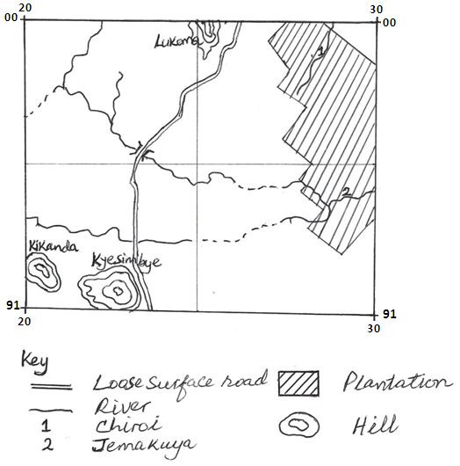

g). (i). Length of the pipe line if it follows the alignment of the existing road

8.6km (**NB:** Accept an answer in the range 8.5 - 8.7km)

**Scoring**

* Scores (1mark) if the response is limited i.e. simply states the length of the pipeline with appropriate units of measure without showing how one arrives at the answer.
* Scores (2marks) if the response provides the calculations leading to the length of the pipeline with appropriate units of measure. (**max** =**2marks**)

(ii).The total cost of piping if each kilometre of the pipeline costs 2 million Uganda shillings.

Sh. 17,200,000= Accept answer in the range 17,000,000-17,400,000=)

**Scoring**

* Scores (1mak) if the response is limited i.e. simply states the total cost of piping appropriate units of measure without showing how he/she arrives at the answer.
* Scores (2marks) if the response provides the calculations leading to the total cost of piping with appropriate units of measure.

**(max** = **2 marks)**

**Question 12**

Fig. 5**,** a photograph taken from an area in East Africa

a) Possible responses

1. Ground photograph/Ground close /Terrestrial photograph (**1mark**)
2. Flat plain/Generally flat land/plateau surface (**1mark**)
3. Vegetation in the foreground: Savanna grassland/wooded savanna grassland/Grassland with shrubs (**1mark)**
4. Vegetation in the background: woodland savanna/forest (**1mark**)
5. Wildlife conservation (**1mark**)

b). (i). **Two** in which the area shown in the photograph can be improved so that it can attract tourists

**Possible responses:**

* Construction of modern roads to ease movement
* Construction of accommodation facilities such as hotels and lodges/rest houses
* Setting up police posts to boost security for tourists
* Development of craft shops for tourists to buy souvenirs
* Establishing recreation facilities such as golf course, swimming pools, sport hunting ground, cinema hall etc.
* Extending power supply to the area e.g. a hydro electricity grid, a solar power station, or a wind power garden etc.

**Scoring**

* Scores (1 mark) if the response is limited i.e. candidate simply lists 1/2 relevant ideas with no explanation.
* Scores (2 marks) if the response presents 2 relevant ideas with limited explanation; or if the response provides 1 valid idea; well explained with a good range of technical terms used appropriately.
* Scores (4 marks) if the response presents 2 valid ideas, well explained, with a good range of technical terms used appropriately.

Such technical terms may include: all weather roads; first class accommodation, cultural tourism, scenery, etc

(**max**= **4 marks**)

(ii). Three likely benefits tourism might bring to the local community in the area

**Possible responses:**

* Employment opportunities for tour guides, drivers, hoteliers etc.
* Market for crafts and foodstuffs produced in the area.
* Improved infrastructure such as roads, power supply, recreation facilities, etc.
* Preservation of cultural heritage in the area
* Introduction of new lifestyles such as ways of dressing, communication etc.

**Scoring**

* Scores (1-2 marks) if the response is limited i.e. simply lists 1-3 relevant ideas with no explanation; or if the response presents one valid idea with clear and detailed explanation.
* Scores (3-4 marks) if the response presents 3 relevant ideas with limited explanation; or if the response provides 2 valid ideas with clear and detailed explanation.
* Scores (5-6 marks) if the response presents 3 valid ideas with 2 well explained but with a mere outline/mention of the other; or if the response presents 3 valid ideas with clear and detailed explanation.

d) Name/identification of the Area --------------------------------------------- (1mark)

**Possible responses:**

* Physical attractions: Landforms, drainage (river, lake, waterfalls etc.), vegetation, animals, and sunny climate/sun rise.
* Human attractions: Sporting (mountaineering, sport fishing, bungee jumping, water rafting, golf etc.); historical site, culture (dressing styles, traditional dances, traditional dishes), traditional architectural designs, place(s) of worship/temple, etc.

**Scoring**

* Scores (1-2marks) if the response simply lists 1-2 tourist attractions in one category or 1 physical attraction and one human attraction.
* Scores (2-4marks) if the response presents 3-4 tourist attractions in the physical and human categories.

**Max** =**5marks**)

**Question 13**

(a)Fig. 3: Demographic Transition Model.

a) What can happen to a country if its death rate rises higher than its birth rate?

* The country’s population can decline drastically since natural increase of population through births is lower than the rate at which the population decreases as a result of deaths.
* The country’s population can decrease since there will be no increase in population at all as the people who die will be more than those born.
* Scores (1mark) if the response is valid and in line with the question (**1mark**)

b) In which stage of the Demographic Transition Model are both birth rates and death rates

high?

**-** In stage 1 (**1mark**)

(**max= 4marks**)

c) Give **four** reasons why birth rates have fallen by the time a country reaches Stage 4 of the model.

**Possible responses:**

* Higher levels of education whereby women stay longer in school thereby delaying to produce children, and are able to apply family planning and birth control methods.
* There is a higher proportion of working women in the country and this reduces fertility rates to about two children per woman.
* Higher levels of economic development whereby people mind more about business and jobs than producing children
* Improved use of contraception which greatly reduces the number of children born in the population.
* A great decline in the value parents attach to children as source of labour and family wealth.
* Higher levels of urbanisation which makes the cost of maintaining a big family higher. So urbanites produce few children.
* Late marriages as women tend to focus more on their careers than having children.
* Higher cost of maintaining a large family.

**Level 1**

Candidate scores (1-2) if the response is limited i.e. simply lists 1-2 relevant reasons with little explanation; or if the response presents one valid reason with clear and detailed explanation and with a limited range of technical terms used appropriately.

**Level 2**

Candidate scores (3-4) if the response presents 3 relevant reasons with limited explanation; or if the response provides 2 reasons; well explained and with a good range of technical terms used appropriately.

**Level 3**

* Candidate scores (5-6) if the response presents 3 reasons, with 2 well explained and illustrated with examples, with a good range of technical terms used appropriately; but with a mere outline/mention of the third reason.
* Score (7-8) if the response provides 3 valid reasons well explained and illustrated with examples; and with a good range of technical terms used appropriately.

Such terms may include death rate, mortality/death rate, fertility rate, etc. (**max**= **8marks**)

d). **I**dentify the stage of the Demographic Transition Model in which Uganda is.

Give reasons to support your answer.

Stage: Stage 2 (**2 marks**)

Reasons:

**Possible responses**

* Uganda is experiencing high birth rate while the death rate is declining.
* Uganda has a very young population (0-18 years) which is characteristic of stage 2.
* In Uganda people still prefer having large families due to social and cultural beliefs.
* The country’s population is still largely employed in subsistence agriculture which can support a rapidly growing population.
* High fertility rates among women which lead to large population increase.
* Death rates are falling due to mass immunization against child killer diseases.
* Improved health facilities and primary health care is leading to falling death rates.
* Death rates are falling due to improved nutrition, hence rising population.

(**8marks**)

**Level 1**

Scores (1-3) if the response is limited i.e. simply lists 1-4 relevant characteristics of Uganda’s population which reflect a country at stage 2 of the model.

**Level 2**

Scores (4-6) if the response presents 4 relevant characteristics of Uganda’s population which are typical of a country at stage 2 of the modal with limited explanation; or if the response provides 2-3 characteristics, well explained with a good range of technical terms used appropriately

**Level 3**

Candidate scores (7-8) if the response presents 4 characteristics of Uganda’s population which are typical of a country at stage 2 of the model well explained with a good range of technical terms used appropriately.

Such terms may include birth rate, mortality/death rate, fertility rate, subsistence, etc. (**max= 10 marks) Total = 20 marks**

GEOGRAPHY EXAMINATION

November/December 2022

|  |  |  |  |
| --- | --- | --- | --- |
| Qn | Marks | | |
| Available | | Actual |
| **SECTION A** | | | |
| 1 | 10 | |  |
| 2 | 10 | |  |
| 3 | 10 | |  |
| 4 | 10 | |  |
| **Sub total** | **40** | |  |
| **SECTION B** | | | |
| Qn….. | 20 |  | |
| Qn…… | 20 |  | |
| **Sub total** | **40** |  | |
| **TOTAL** | **80** |  | |

## Paper2

**2 hours**

**Uganda Certificate of Education**

**Geography Examination**

**PAPER 2**

**2 hours**

**INSTRUCTIONS TO CANDIDATES:**

1. This paper consists of **two** sections: **A** and **B**
2. In section **A**, write the answers in the space provided.
3. For section **B**, write the answers in the booklet provided
4. The invigilator will tell you when you have 10 minutes to end of examination
5. The marks for each section are shown in brackets; use this as a guide of how much time to spend on each question.
6. Use a calculator and mathematical instruments where applicable.

**ADVICE**

1. Read the whole question before answering-especially if there is more than one part to the question.
2. If you finish early, check your answers

**SECTION A: SHORT RESPONSE QUESTIONS (40 MARKS)**

**Answer all questions in this section.**

**Question 1**

Figure 1 shows a Stevenson screen, the container used to store instruments at a weather station. Features of the design have been labelled.

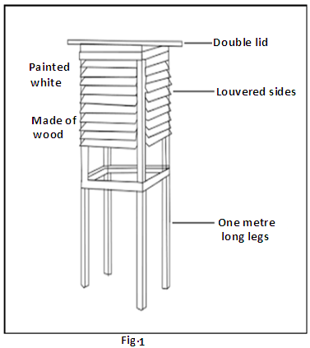

a). Choose **two** of the features labelled in Fig.1. For each of the features you have chosen, explain why the Stevenson screen has been designed in this way.

Feature………………………………………………………………………………………………………………………………………

Explanation…………………………………………………………………………………………………………………………………

……………………………………………………………………………………………………………………………………………………

……………………………………………………………………………………………………………………………………………………

Feature……………………………………………………………………………………………………………………………………….

Explanation…………………………………………………………………………………………………………………………………

……………………………………………………………………………………………………………………………………………………

………….………………………………………………………………………………………………………………………………………… (**4**)

b). One of the instruments stored in the Stevenson screen is the hygrometer (wet and dry bulb thermometers). This is shown in Fig. 2 below. The readings of the wet and dry bulb thermometers are used to calculate the relative humidity using the conversion table shown as Table 1 below.

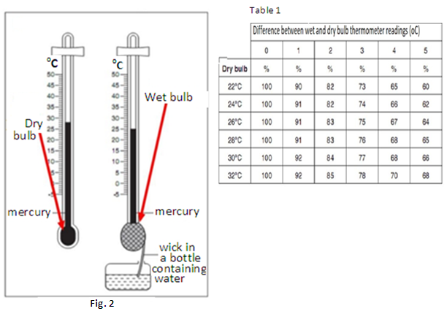

1. State the readings of the wet and dry bulb thermometers in Fig. 2.

Wet bulb………………………………………………………………………………………………… (**1**)

Dry bulb………………………………………………………………………………………………… (**1**)

1. Calculate the difference between the wet and dry bulb thermometer readings

…..………………………………………………………………………………………………………………..

(**1**)

1. Using your answers to b(i) and (ii), and Table 1, determine the relative humidity.

………………….……………………………………………………………………………………………………

(**1**)

c) Explain **one** way in which people in your community use the knowledge of relative humidity in carrying out their activities.

……………………………………………………………………………………………………………………………………………………

……………………………………………………………………………………………………………………………………………………

……………………………………………………………………………………………………………………………………………………

……………………………………………………………………………………………………………………………………………………

……………………………………………………………………………………………………………………………………………………

……………………………………………………………………………………………………………………………………………………

……………………………………………………………………………………………………………………………………………………

(**2**)

**Question 2**

Look at Fig. 3 below, a map showing the Gezira irrigation scheme. Use it to answer the questions which follow.

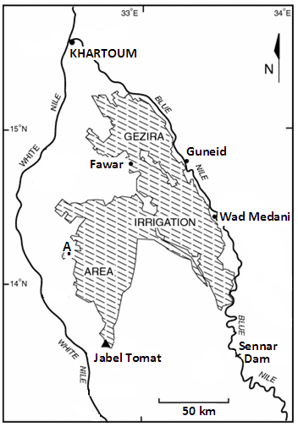

**Fig. 3**

The Gezira scheme is currently the largest irrigation scheme under one management in the world covering about 1 million hectares.

a) Suppose you visited the Gezira Scheme today, calculate the distance you would cover if you drove along a straight line road from Wadi Medani town to the place marked **A** on the map.

……………………………………………………………………………………………………………………………………………………

……………………………………………………………………………………………………………………………………………………

………………………………………………………………………………………………………………………………………(**2**)

b) What is the bearing of Sennar Dam from Fawar town?

………………………………………………………………………………………………………………………………………………………………………………………………………………

………………………………………………………………………………………………………………………………………………………………………………………………………………………………………………………………………………………………………………………………………………………………………………………………………………………………………………………………………………………………………………………………………………………………………………………………………………………………………………

(**2**)

b) Explain how river Nile has contributed to the development of the irrigated area marked on the map.

……………………………………………………………………………………………………………………………………………………

……………………………………………………………………………………………………………………………………………………

……………………………………………………………………………………………………………………………………………………

…………………………………………………………………………………………………………………………………………………… (**4**)

c) Imagine you have been given a very large piece of farm land in one of the semi-arid areas of Uganda.

Explain **two** methods of irrigation which you would use to make your land suitable for farming throughout the year.

……………………………………………………………………………………………………………………………………………………

……………………………………………………………………………………………………………………………………………………

……………………………………………………………………………………………………………………………………………………

………………………………………………………………………………………………………………………………………

…………………………………………………………………………………………………………………………………………………… (**2**)

**Question 3**

Study Fig. 4, a map of Africa showing population density and answer the questions which follow.

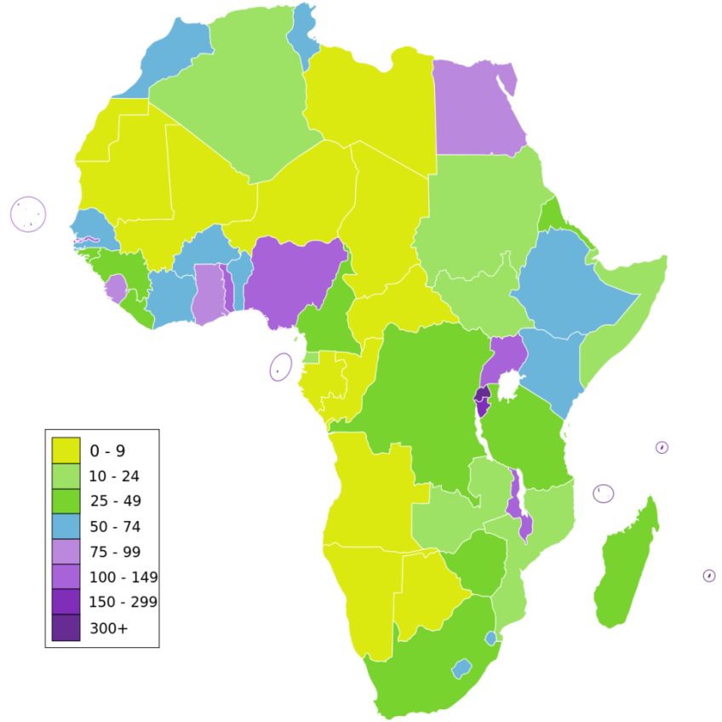

**Fig. 4**

a (i) Identify **two** countries with a population density of more than 150 persons per square kilometer.

……………………………………………………………………………………………………………………………………………………

……………………………………………………………………………………………………………………………………………………

(**2**)

ii) Given that 211,400,700 people live on 923,800km2of land in Nigeria, calculate the population density of the country.

……………………………………………………………………………………………………………………………………………………

……………………………………………………………………………………………………………………………………………………

……….……………...…………………………………………………………………………………………………………………………… (**2**)

iii) According to Figure 4, much of northern Africa has low population density.

Explain why this region has such low population density.

..........................................................................................................................................................

……………………………………………………………………………………………………………………………………………………

……………………………………………………………………………………………………………………………………………………

….………………………………………………………………………………………………………………………………………………… (**4)**

b) Do you think Uganda should control her rapidly growing population? Give **two** reasons for your answer.

……………………………………………………………………………………………………………………………………………………

……………………………………………………………………………………………………………………………………………………

………………………………………………………………………………………………………………………………………

(**2**)

**Question 4**

Look at Fig. 5 below showing a modern method of fishing. Use it to answer the questions which follow.

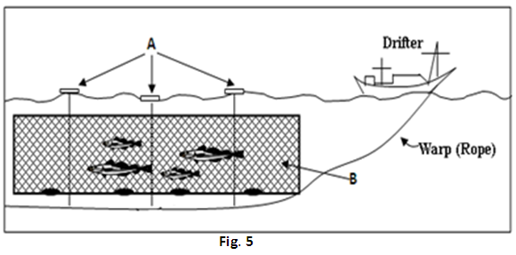

1. Name the parts marked:
2. A---------------------------------------------------------- (**1**)

1. B---------------------------------------------------------- (**1**)

b) Give **two** reasons why you may recommend the fishing method shown in Fig.5 to be used by fishermen in East Africa.

-------------------------------------------------------------------------------------------------------------------------------

-------------------------------------------------------------------------------------------------------------------------------

-------------------------------------------------------------------------------------------------------------------------------

-------------------------------------------------------------------------------------------------------------------------------

-------------------------------------------------------------------------------------------------------------------------------

-------------------------------------------------------------------------------------------------------------------------------

-------------------------------------------------------------------------------------------------------------------------------

-------------------------------------------------------------------------------------------------------------------------------

(**4**)

1. For a named fishing ground you have studied, explain **four** problems facing the fishing industry in East Africa.

--------------------------------------------------------------------------------------------------------------------------

--------------------------------------------------------------------------------------------------------------------------

--------------------------------------------------------------------------------------------------------------------------

--------------------------------------------------------------------------------------------------------------------------

(**4**)

**SECTION B: EXTENDED RESPONSE QUESTIONS (40 MARKS)**

Answer **two** questions from this section.

**Question 5**

Table 1 below shows the imports of goods and services by value (in million US dollars) from countries X and Y. Use the table to answer the questions which follow.

|  |  |  |  |  |  |
| --- | --- | --- | --- | --- | --- |
| **Country** | **2006** | **2007** | **2008** | **2009** | **2010** |
| X | 2829 | 3581 | 4618 | 5557 | 5833 |
| Y | 8514 | 10,268 | 12,719 | 11,196 | 12,192 |

*Adapted from: African Development Indicators 2012/13*

1. Draw a graph to show the value of imports between 2006 and 2010 for countries X and Y. (*You can use the squared paper at the end of this booklet*) (**10**)
2. Using the graph you have drawn in (a) above, describe the trend of imports between 2006 and 2010 for country Y.

(**4**)

1. For nearly 20 years now, Uganda is trying to develop industries which process agricultural, minerals and other primary products. The main aim is to improve the country’s participation in international trade.

Explain how this might affect the country’s export and import trade.(**6**)

**Question 6**

a) Describe the characteristics of hot desert climate. (**4**)

b) Explain **four** factors influencing the climate of Africa. (**8**)

c) For a named climatic region of Africa, explain the effects of climate on people’s ways of life. (**8**)

**Question 7**

Study Fig. 5, a map of China showing migration to major cities and use it to answer the questions which follow.

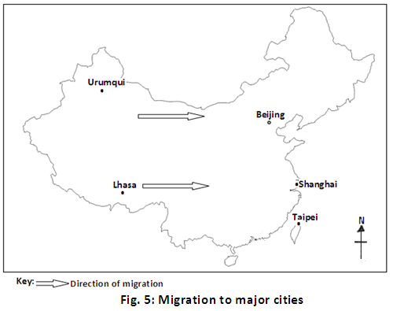

1. Give reasons why many people in China move from rural areas to live in towns and cities like Shanghai.

(**4**)

1. Describe the problems that cities face as a result of the increased number of migrants.

(**6**)

1. Imagine you are the Mayor of **one** of the cities shown on the map in Figure 5; suggest measures which you would take to solve the problems facing the city. (**10**)

**Question 8**

All nations around the world shall be affected by the impact of climate change. However, the poorest nations will be hit the hardest. Time is now for African countries to act and reduce the impact of climate change. All countries, regardless of their level of development, must look to reduce the amount of carbon dioxide they send into the air. We must prevent further warming and reverse the trend. (Lopes, UNECA)

1. Describe the signs which show that climate change is taking place in Uganda. (**6**)
2. Explain the causes of climate change. (**6**)
3. Using the lessons learnt from the tree planting project in which you have taken part, explain why planting trees alone might not reduce the effects of climate change. (**8**)

**Question 9**

1. Distinguish between a volcanic mountain and a block mountain. (**4**)
2. Using diagrams, explain how the Block Mountains in East Africa were formed. (**8**)
3. Adam and his family live on one of the slopes of a block mountain in Kenya.

Explain the likely problems faced by Adam’s family as a result of living in such an area.

(**8)**

**UCE**

Uganda Certificate of Education

-----------------------------------------------------------------------------------------------

Geography Sample Assessment

**Paper 2**

-----------------------------------------------------------------------------------------------

## MARKING GUIDE

**General Marking Guidelines**

**Introduction**

This marking guide is intended to ensure that UCE examination is marked consistently and fairly. The scheme provides examiners with an indication of the nature of candidates’ responses likely to be worth of credit. It also sets out the criteria which the examiners should follow while allocating marks to candidates’ responses. The marking scheme should be read in conjunction with these general marking guide lines.

**Assessment objectives**

Below are the assessment objectives for UCE Geography.

Candidates should demonstrate that they are able to:

* Recall, select and communicate their knowledge and understanding of places, environments and concepts (AO1);
* Apply their knowledge and understanding in both familiar and unfamiliar contexts (AO2);
* Select and use a variety of skills, techniques and equipment to investigate, analyse and evaluate tasks and issues (AO3);
* Use their knowledge and understanding to form personal opinions about, and demonstrate appreciation of situations, issues and problems (AO4).

**Quality of candidates, responses**

In marking candidates’ scripts, examiners should be looking for a quality of response reflecting the level of maturity which may reasonably be expected of a 16- or 17- year old which is the age at which majority of the candidates sit their end of Lower secondary education cycle examination.

**Flexibility on marking**

This marking scheme is not intended to be prescriptive. It does not cover all the responses which candidates may produce. In the event of unexpected answers, examiners are expected to use their professional judgment to assess the validity of responses. If an answer is particularly problematic, then examiners should seek the guidance of the Chief Examiner.

**Positive marking**

Examiners are expected and encouraged to be positive while judging candidates’ work. They should give appropriate credit for what candidates **know**, **understand**, **can do** and **opinions they hold about a situation** rather than penalise them (candidates) for errors or omissions. Examiners should make use of the whole of the available mark range for any particular question and be prepared to award full marks for a response which is as good as might reasonably be expected of a 16- or 17-year old candidate.

**Awarding Zero marks**

Marks should only be awarded for valid responses and no mark should be awarded for a response which is completely incorrect or inappropriate.

**Awarding types of response**

Items or questions which require very short answers/responses should be marked on **a point for point basis** where marks are awarded for each valid piece of information provided by the candidate.

Questions or tasks which require candidates to respond in a more detailed form should be marked on the basis of levels of response which take into account the quality of written communication.

**Levels of response**

* **Marginal Performance**: Response which just merits in the level and should be awarded a mark at or near the bottom of the range.
* **Moderate Performance**: Response which clearly merits inclusion in the level and should be awarded a mark in or near the middle of the range.
* **Outstanding Performance**: Response which fully satisfies the level description and should be awarded a mark at or near the top of the range.

**Marking calculations**

In judging and awarding responses involving mathematical calculations, examiners should apply the “**own figure rule**” in order to avoid penalizing candidates more than once for a computation error.

**SECTION A: SHORT RESPONSE QUESTIONS (40 MARKS)**

**Question 1**

Figure 1: Stevenson screen

a). Choose **two** of the features labeled in Figure 1. For each of the features you have chosen, explain why the Stevenson screen has been designed in this way.

**Possible responses:**

* Feature:Made of wood/wooden box

Explanation: It is to prevent absorption and conduction of heat which would lead to a rise or fall in temperature around the thermometers thus affecting recordings.

* Feature: Louvered sides

Explanation: This is to allow free circulation of air into and out of the box. This enables thermometers to record actual air temperature.

* Feature: Box painted white
* Explanation: To reflect excessive heat back into the atmosphere to prevent over heating inside the box.
* Feature: It has 1meter long legs

Explanation: To avoid ground weather conditions from affecting the readings recorded the instruments inside the box.

* Feature: It has a double roof

Explanation: To reduce excessive heat from the sun (solar irradiation).

**Any 2 features, each 2 marks**

* Identification of feature….1 mark
* Explanation………….1 mark (**max**= **4marks**)

b). Figure 2 and Table.

1. State the readings of the wet and dry bulb thermometers in Figure 3.

* Wet bulb thermometer reading: 25oC (**1mark**)
* Dry bulb thermometer reading: 28 oC (**1mark**)

1. Calculate the difference between the wet and dry bulb thermometer readings

* Difference in thermometer readings = 28oC - 25oc = 03oC (**1mark**)

1. Using your answers to b(i) and (ii), and Table 1, determine the relative humidity

* Relative humidity = 76 percent (**1mark**)

**(max = 4 marks)**

c) Explain two ways in which people in your community use the knowledge of relative humidity in carrying out their activities.

**Possible responses:**

* Washing and drying their clothes
* Drying their crop harvest such as grain, beans, coffee, cassava etc.
* Playing games and sports- find it hard to play on a hot day with high relative humidity.
* Watering their gardens
* Scores (1) if the response is limited i.e. simply states one valid way in which relative humidity affects the way of life in their community without explanation.
* Scores (2) if the response presents 1 way in which relative humidity affects ways of life in their community with clear and detailed explanation, with a good range of technical terms used appropriately.

E.g. Activities such as drying harvested crop is done best when relative humidity is low. This is when the atmosphere is thirsty and absorbs a lot of water from the earth’s surface. This makes cereals, cassava and other crops spread out under the sun dry fast.

(**2 marks**)

**Question 2**

a) Suppose you visited the Gezira Scheme today, calculate the distance you would cover if you drove along a straight line road from Wad Medani town to the place marked **A** on the map.

100 – 110 Km

b) What is the bearing of Sennar Dam from Fawar town?

140 – 145 Degrees

b) Explain the factors which favoured the establishment and development of the irrigated area marked on the map.

**Possible responses:**

* Presence of fairly fertile soils which favour the growth of crops.
* Availability of a permanent source of water for irrigation - the Blue Nile.
* The arid/dry climate with hot temperatures encourages the growth and ripening of crops like beans, cotton, dura (sorghum), millet etc/climate of the Gezira Plains is quite dry and does not favour most crop pests and diseases.
* The gently sloping relief or plains make irrigation cheap and easy because water can flow to the farms under the influence of gravity.
* Availability of large sums of capital provided first, by the British and later by the Sudan government.
* The soils below the silt (alluvial deposits) have a high clay content which prevents loss of water by underground seepage.
* The area has a good water table which does not allow water logging to occur.
* Availability of extensive farm land.
* The establishment of the scheme found the people of Sudan with some knowledge and experience of irrigation farming.
* A large supply of cheap casual labour during the peak periods of planting and harvesting especially by people from the dry farming areas of Sudan.

**Level 1**

Scores (1) if the response is limited i.e. simply lists 2 valid factors; or if the response presents one valid factor with clear and detailed explanation of how it has favoured the establishment and development of irrigation on the Gezira Plains; with technical terms used appropriately.

**Level 2**

Scores (2) if the response merely lists or outlines 3 valid factors; or if the response provides 2 valid factors with clear and detailed explanation; with a good range of technical terms used appropriately.

**Level 3**

* Scores (3) if the response presents 4 valid factors with detailed explanation but with a limited range of technical terms used appropriately; if the response presents 3 valid factors with clear and detailed explanation and with a god range of technical terms used appropriately.
* Scores (4) if the response presents 4 valid factors with clear and detailed explanation and with a good range of technical terms used appropriately.

**Such terms may include:** water logging, underground seepage, water proof, aridity, casual labour, extensive land, gravity flow etc**.**

(**4marks**)

c) Imagine you have been given a very large piece of farm land in one of the semi-arid areas of Uganda. Explain **two** methods of irrigation which you would use to make your land suitable for farming throughout the year.

**Possible responses:**

* Shadufs
* The Sakia
* Archimedean Screw or Tambour
* Basin Irrigation
* Canal Irrigation/Gravity flow
* Storage tanks
* Drip Irrigation using pipes with several holes or jets/bottles
* Overhead Irrigation/sprinklers

**Level 1**

Scores (1) if the response is limited i.e. candidate simply lists 2 valid irrigation methods; or if the response presents one valid method with clear and detailed explanation of how it works; with technical terms used appropriately.

**Level 2**

Scores (2) if the response presents 2 valid irrigation methods with clear and detailed explanation of how each one works to supply water to the farm; with a good range of technical terms used appropriately.

**Any 2** methods x**2** (**4 marks**)

**Question 3**

Figure 4: Map of Africa showing population density

a (i) Identify **two** countries with a population density of more than 150 persons per square kilometer.

Egypt, Uganda, Rwanda, Burundi, Malawi, Gambia Any 2 countries x1 mark

(**max= 2marks**)

ii) Given that 211,400,700 people live on 923,800km2 of land in Nigeria, calculate the population density of the country.

PD= Total population/Land area

PD of Nigeria: 211,400,700/923,800km2 =229 persons/square kilometer (**1mark**)

iii) According to Figure 4, much of northern Africa has low population density. Explain why this region has such low population density.

**Possible responses:**

* Very hot temperatures which discourage crop cultivation and livestock farming.
* Semi desert and desert climate with low rainfall hinder settlement, crop cultivation and livestock farming.
* Presence of sandy and infertile soils which discourage arable farming and livestock farming
* Limited supply /scarcity of surface water which discourages settlement
* Poorly developed transport system across the Sahara desert

**Level 1**

Scores (1) if the response is limited i.e. simply lists 2 valid factors; or if the response presents one valid factor with clear and detailed explanation of how it has led to low population density in the region.

**Level 2**

Scores (2) if the response merely lists or outlines 3 valid factors; or if the response provides 2 valid factors with clear and detailed explanation; with a good range of technical terms used appropriately.

**Level 3**

Scores (3-4) if the response presents 3 valid factors with clear and detailed explanation of how each has led to low population density; and with a good range of technical terms used appropriately.

(**4marks**)

b) Do you think Uganda should control her rapidly growing population? Give reasons for your answer.

**Possible responses:**

**YES**; because of the following reasons

* Shortage of land leading to land conflicts
* Over utilization of resources leading to soil erosion, destruction of wetlands, forests etc.
* Easy spread of diseases due to congestion.
* High government expenditure social services.
* Rising levels of unemployment at regional and national levels.
* Low levels of savings by families as much of the income is spent on day-to-day consumer goods and services
* Strain on social services such as schools, medical facilities, water supplies etc.

**No**; because of the following reasons;

* Provision of labour to work in industries, farmland etc.
* Encourages profitable use of idle resources such as land and minerals.
* Provision of ready market for agricultural commodities and manufactured goods.
* It increases government revenue as taxes are collected from many people.
* It stimulates the provision of social services and development of infrastructure
* Provision of enough security for the country etc.

**Level 1**

Scores (1) if the response is limited i.e. simply provides a stand point with 1 valid reason to support it; if the response presents 1 well explained valid reason with no stand point.

**Level 2**

Scores (2) if the response merely provides a stand point and 2 reasons with limited explanation to justify the stand point.

**Level 3**

Scores (3) if the response presents a stand point with two valid reasons to defend the stand point, well explained and illustrated with relevant examples and with a good range of technical terms used appropriately.

Such terms may include: environmental deterioration/degradation, imbalance, unemployment, underemployment, congestion/overcrowding etc.

(**max** = **3 marks**)

**Question 4**

Figure 4: A modern method of fishing

1. Name the parts marked;
2. A: floats (**1mark**)
3. B: fishing net /drift net (**1mark**)

b) Give **two** reasons why you may recommend the fishing method shown in Fig. 4 to be used by fishermen in East Africa.

**Possible responses:**

* Drifting is very efficient for large scale commercial fishing.
* It is less destructive than other large scale fishing methods since it does not catch fish of all sizes.
* Not very expensive/ relatively cheaper than other modern methods/no baits needed.
* Cannot easily be damaged by the lake /sea floor since it is not dragged or pulled along.

**Level 1**

Scores (1mark) if the response simply provides two valid reasons with limited or no detailed explanation; or if the response presents 1 well explained valid reason

**Level 2**

Scores (2-3marks) if the response provides 2 valid reasons with clear and detailed explanation of 1 reason; and limited explanation of the other reason with some distortions

**Level 3**

Scores (4marks) if the response presents two valid reasons, each well explained with no distortions and with a good range of technical terms used appropriately

Such terms may include: ruggedness, overfishing, sea floor etc. (**4 marks**)

1. For a named fishing ground you have studied, explain **four** problems facing the industry fishing in East Africa.

**Possible responses:**

* Pollution of water bodies by wastes from factories, towns and mines.
* Lack of efficient modern fishing gear/ limited capital for investment in the fishing industry.
* Catching too many young fish leads to exhaustion of fish stocks/ Overfishing
* Poor preservation methods/ use of inefficient fish preservation methods
* High taxes levied on fishermen discourage many potential fishers.
* The local market for fish is still very small.
* Remoteness of the fishing grounds/Poor transport facilities
* Invasion of the fishing ground by the water hyacinth which hinders the movement of fishing craft, use of gill nets and circulation of oxygen in water.
* Fluctuation of water volumes due to prolonged droughts. This interferes with the breeding of fish and the fishing activities.
* Presence of other aquatic animals like crocodiles and otters which eat the fish and damage fishing baskets and nets.

**Level 1**

Scores (1) if the response simply provides two valid problems limiting the development of fishing in East Africa with limited or no detailed explanation; or if the response presents 1 valid problem with clear and detailed explanation

**Level 2**

Scores (2) if the response provides 3 valid problems with clear and detailed explanation of 2 problems reason; and limited explanation of the other problem with some distortions

**Level 3**

* Scores (3) if the response presents 3 valid problems, each well explained with no distortions and with a good range of technical terms used appropriately.
* Scores (4) if the response presents 4 valid problems, each well explained with no distortions and with a good range of technical terms used appropriately.

(**max** = **4marks**)

**SECTION B: EXTENDED RESPONSE QUESTIONS (40 MARKS)**

**Question 5**

Table1: Imports of goods and services by value (in million US dollars) from countries X and Y.

**Possible responses:**

a)  **Either**: A graph showing the value of imports between 2006 and 2010 for countries x and y

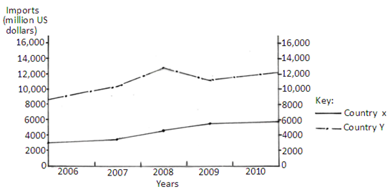

**Or**: A graph showing the value of imports between 2006 and 2010 for countries x and y

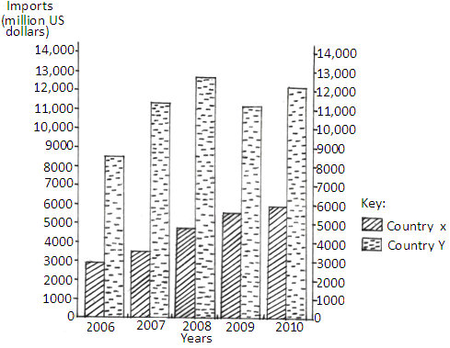

-title………………………………(1)

-labelled axes…………………(2)

-plotting…………………………(4) **2 marks** for accurately marked coordinates for each line

-key………………………………..(1) (**max**= **08 marks**)

b) The trend of imports between 2006 and 2010 for country Y.

* Between 2006 and 2007 the value of imports of country Y increased more than those of country X from 8514 million us dollars to 10,268 million us dollars
* Between 2007 and 2008 there was an increase in the value of imports from 10,268 million us dollars to 12,719 million us dollars
* Between 2008 and 2009 there was a decline in the value of imports from 12,719 million us dollars to 11,196 million us dollars
* Between 2009 and 2010 there was an increase in the value of imports from 11,196 million us dollars to 12,192 million us dollars.
* The imports of country Y rose sharply between 2007 and 2008. This was followed by a sharp decrease between 2008 and 2009.
* The imports of country Y experienced a slight increase between 2009 and 2010.
* The volume of imports for country X rose steadily from 2006 to 2009while it remained almost constant between 2009 and 2010.
* Generally, the volume of imports for country Y fluctuated more than those of country X over the period.

**Scoring**

**Level 1**

Scores (1) if the response simply lists or outlines 2 relevant aspects of the trend with limited or no magnitude /evidence of change from the graph

**Level 2**

Scores (2) if the response provides 4 valid aspects of the trend with no clear magnitude of change/evidence from the graph; or if the response provides a clear description of one aspect with a magnitude of change/evidence from the graph, and merely mentions the other 3 aspects.

**Level 3**

* Scores (3) if the response presents 4 valid aspects of the trend, with clear and detailed description of 2 with a magnitude of change/evidence from the graph; and limited explanation of the other2.
* Scores (4) if the response presents 4 valid aspects of the trend with clear and detailed description and illustrated with evidence from the graph/magnitude of change.

**(max = 4marks)**

c) For nearly 20 years now, Uganda is trying to develop industries which process agricultural, mineral and other primary products. The main aim is to improve the country’s participation in international trade.

Explain how this might affect the country’s export and import trade.

**Possible responses:**

* Uganda will be able to export processed and manufactured goods instead of semi processed raw materials.
* Processed products will attract more demand and this will widen the country’s export market.
* Export trade will fetch higher income since a large volume of export goods will be processed or manufactured products
* Goods which can be manufactured locally goods will no longer have to be imported/ import substitution
* Much of Uganda’s import trade will consist of producer goods such as machinery to boost her local industries. Etc.

**Scoring**

**Level 1**

Candidate scores (1-2) if the response simply lists or outlines 2 relevant effects with limited or no magnitude explanation; and with no technical term used

**Level 2**

Scores (3-5) if the response provides 4 valid effects with limited explanation and with a small range of technical terms used appropriately; or if the response presents 3 effects, with clear and detailed explanation with a fairly good range of technical terms used appropriately, and merely lists 1 effect.

**Level 3**

Scores (6-8) if the response presents 4 valid effects with clear and detailed explanation; a good range of technical terms used appropriately, and illustrated with some examples (**max**=**8marks**)

**(Total 20 marks)**

**Question 6**

a) Characteristics of hot desert climate

**Possible responses:**

* Very hot temperatures during the day
* Low night temperatures, sometimes falling as low as 5oC
* Temperatures range between (complete this sentence).
* High wind velocities/ strong winds
* Clear sky/ Limited cloud cover
* Very low rainfall, less than 250mm annually
* Low relative humidity

**Scoring**

**Level 1**

Scores (1) if the response simply lists or outlines 2 valid characteristics of hot desert climate or if it presents one characteristic with reasonable detail

**Level 2**

Scores (2) if the response provides 4 valid characteristics of hot desert climate with limited details; or if the response presents one characteristic with good detail and merely lists other 2 characteristics.

**Level 3**

* Scores (3) if the response presents 4 valid characteristics with detailed description of 2 and merely mentions 2.
* Scores (4) if the response presents 4 valid characteristics all with detailed description.

(**max**= **4marks**)

b Factors influencing the climate of Africa

**Possible responses:**

* Location within the tropics makes its climate affected by the convergence zone for air masses
* Nearness to large water bodies like Atlantic and Indian ocean etc. /land and sea breezes
* The coast of Africa is more or less straight hence prevailing wind tend to blow parallel to the coast causing aridity in some parts such as Somalia, and Nyika plateau.
* Distribution of vegetative cover. Forested areas have high humidity through evapo-transpiration hence creating heavy rainfall.
* Relief rainfall is received on the wind ward side of the highlands because of warm ascending winds while the leeward side remains dry due to dry descending winds.
* Warm ocean currents like Mozambique, Guinea form rain and warm the adjacent areas whereas cold currents cause dry and misty conditions to the adjacent areas for example the cold canaries the Benguela currents
* Prevailing winds for example south east monsoon, a warm current, westerlies form rainfall because they are moisture laden whereas the dry laden winds like north east trade winds and the harmattan winds cause dry conditions in areas where they blow etc.

**Scoring**

**Level 1**

Scores (1-2) if the response simply lists or outlines 1-3 valid factors reasons with limited or no detailed explanation; with a limited range of technical terms used appropriately.

**Level 2**

Scores (3-5) if the response provides 5 valid factors with clear and detailed explanation of 3 factors; and limited explanation of the other 2 factors with some distortions, with a limited range of technical terms used appropriately

**Level 3**

* Scores (6-8) if the response presents 5 valid factors, with clear and detailed explanation of 4 factors; and limited explanation of the other factor with some distortions, with a good range of technical terms used appropriately.
* Scores (9-10) if the response presents 5 valid factors, with clear and detailed explanation of; a good range of technical terms used appropriately and illustrated with some examples. (**max**= **10marks**)

c) Effects of climate on people’s ways of life in a named climatic region of Africa.

**Possible responses:**

* Affects the nature of houses/shelter constructed by the inhabitants.
* Influences the dressing styles.
* Affects the types of crops grown by the inhabitants and/ or the animals reared
* Determines the ways or methods of farming used i.e. sedentary, transhumance or migratory
* Influences people’s feeding habits as it affects the staple foods
* Influences the range of economic activities carried out. E.g. it favours the growth of forests and associated activities such as lumbering, hunting, gathering etc.

**Scoring**

**Level 1**

Scores (1-2) if the response simply lists or outlines 3 valid ways climate influences people’s life styles in the named climatic region.

**Level 2**

Scores (3-4) if the response provides 3 valid effects o climate on life styles with limited details; or if the response presents one influence of climate on life style with good detail and a technical terms used appropriately.

**Level 3**

Scores (5-6) if the response presents 3 valid ways climate affects life styles in the named climatic region with detailed good details, with technical terms used appropriately.

(**max=6marks**) **(Total 20 marks)**

**Question 7**

Fig. 5, a map of China showing migration to major cities

a) Explain why many people in China move from rural areas to live in towns and cities like Shanghai.

**Possible responses:**

* For work/employment opportunities in towns.
* Farming systems in rural areas have changed thereby allowing many people to leave farmland.
* Newly industrialised areas need workers.
* There is a belief that the standard of living is better in cities than in rural areas.
* Better educational and health facilities in towns.
* Business opportunities in towns and cities.

**Scoring**

**Level1**

Scores (1-2) if the response is limited i.e. simply states 2 valid reasons why people in China migrate to towns and cities or a brief outline of one reason, with a limited range of technical terms used appropriately.

**Level 2**

Scores (3-4) if the response provides 3 reasons; with a clear and detailed explanation of 2 with a good range of technical terms used appropriately; and mere identification or outline of the other

**Level 3**

Scores (5-6) if the response presents 4 reasons with clear and detailed explanation and with a good range of technical terms used appropriately. (**6marks**)

d) Using your knowledge of urbanisation in China and any other knowledge, explain the measures which can be used by the government of Uganda to control rural - urban migration.

**Possible responses:**

* Through household registration system similar to “Hukou system” in China which regulates internal migrations.
* Establishing migration permits similar to the “Blue-stamp” in China whereby all intending migrants must buy these permits before moving to urban areas.
* Improving the living conditions in rural areas through provision of social amenities.
* Investing in rural industrialisation in order to create more jobs in rural areas.
* Reducing imbalance between rural and urban wages.

**Scoring**

**Level 1**

Scores (1) if the response simply states 2 valid measures used in China with limited explanation or a brief outline of one valid policy with a limited range of technical terms used appropriately.

**Level 2**

Scores (2) if the response provides 3 measures/policies from China but with a clear and detailed explanation of 2 with a limited range of technical terms used appropriately; and mere identification of the other; or if the response presents 2 policies well explained with a good range of technical terms used appropriately.

**Level 3**

Scores (4) if the response provides 3 valid policies with clear and detailed explanation with a good range of technical terms used appropriately. (max=**4marks**)

**Question 8**

a) Describe the signs which show that climate change is taking place in Uganda.

**Possible responses:**

* Occurrence of extreme weather events such as erratic rains, whirl winds, hail storms
* Sudden change in seasons like receiving rainfall in the month of July and dry spells or little rainfall in March to May
* Rising atmospheric temperatures
* Limited or no fog experienced in the valleys of Kabale
* Melting of ice caps on the peaks of Mount Rwenzori
* Frequent occurrence of floods in the Lake Victoria basin, Teso region and in Kasese.
* Fluctuations (rising and falling) in water levels in large lakes such as Lake Victoria.
* Rising shortage of water in some parts of the country.

**Scoring**

**Level 1**

Candidate scores (1) if the response simply states 3 valid ideas.

**Level 2**

Scores (2-4) if the response provides 3 valid ideas with a clear and detailed explanation of 2 but with a limited range of technical terms used appropriately; or if the response presents 2 valid ideas well explained with a good range of technical terms used appropriately.

**Level 3**

Candidate scores (5-6) if the response provides 3 valid ideas with clear and detailed explanation with a good range of technical terms used appropriately. (**max=6marks**)

b) Explain the causes of climate change.

**Possible responses:**

* Industrial farming and ranching/animal feed lots release large amounts of methane and carbon dioxide into the atmosphere.
* Deforestation in all parts of the world reduces the amount of the carbon sinks
* The use of nitrogen-rich fertilizers on farmland increases the amount of heat cropland can store
* Oil and natural gas drilling emits carbon dioxide into the atmosphere
* Poor garbage disposal. As trash breaks down in landfills, it releases methane, carbon dioxide and nitrous oxide gases
* Burning of fossil fuels such as coal, petroleum and natural gas which send large amounts of carbon dioxide into the air.
* Transportation. Increasing traffic on the roads and in the air has led to increased emission of carbon dioxide which increases air temperature. E.g. globally, 2% of all CO2 emissions are from air travel.
* Burning of vegetation (trees and other plants) transfers their stored carbon into atmospheric carbon dioxide.
* The melting of permafrost releases tons of trapped greenhouse gases which further speeds up the melting of more permafrost.
* Volcanic Eruptions. Volcanoes emit large quantities of carbon dioxide when they erupt.

**Scoring**

**Level 1**

Candidate scores (1) if the response simply states 3 valid causes of climate change.

**Level 2**

Scores (2-4) if the response provides 3 valid causes of climate change with a clear and detailed explanation of 2 but with a limited range of technical terms used appropriately; or if the response presents 2 valid ideas well explained with a good range of technical terms used appropriately.

**Level 3**

Candidate scores (5-6) if the response provides 3 valid causes of climate change with clear and detailed explanation with a good range of technical terms used appropriately.

(**max=6 marks**)

c) Using the lessons learnt from the tree planting project in which you have taken part, explain why planting trees alone might not reduce the effects of climate change.

**Possible responses:**

* Trees take long to mature and to have effect on carbon emissions in the atmosphere
* Trees do not provide the food and other agricultural products.
* There is need to ensure water supplies which cannot be got from trees.
* Planting trees cannot stop other sources of greenhouse gases such as poor waste disposal and animal feed lots
* Planted trees may not be preserved if not followed by use of alternative sources of energy
* Trees take long to mature and to contribute to rain formation so as to reduce aridity and droughts
* Trees need a lot of care to reach maturity and improve climate.
* Trees can be affected by some effects of climate change e.g. prolonged drought, wild fires etc.
* Trees need to be followed by education of the masses about their value; otherwise local people will cut them down.

**Scoring**

**Level 1**

Scores (1-3) if the response merely lists 1-4 reasons why tree planting might not be enough to reduce the effects of climate change.

**Level 2**

Scores (4-6) if the response 4 relevant ideas with two well explained and the others just mentioned with a limited range of technical terms used appropriately

**Level 3**

Scores (7-8) if the response 4 relevant ideas well explained with a good range of technical terms used appropriately

**8marks**

**(Total 20marks)**

**Question 9**

a) Distinguish between a volcanic mountain and a block mountain.

**Possible responses:**

* A volcanic is formed by the eruption of molten rock while a Block mountain is an upland formed due to displacement of land blocks along cracks/fault lines.
* A volcanic mountain can be strato or shied in shape while a block mountain is made of blocks lying at different levels.
* A volcanic mountain consists of igneous rocks only while a block mountain can be made up of more than one type of rock e.g. sedimentary and metamorphic rocks.

(**4marks**)

**Scoring**

* Scores (1-2) if the response presents the ideas without contrasting the two types of mountains.
* Scores (3) if the response presents one two ideas; one well-articulated and the other merely mentioned.
* Scores (4) if the response presents two ideas well explained and illustrated.

b) Using diagrams, explain how the Block Mountains in East Africa were formed.

**Possible responses:**

* Block Mountains are formed when forces operating within the interior of the earth pull the land block from the centre into opposite directions /push the land block from opposite sides towards the centre.
* When forces push the land bloc from opposite sides, parallel cracks or fault lines occur.
* The block of land between the fault lines may be raised higher than the side blocks resulting in the formation of a Block Mountain or a horst.
* When the forces pull the land block into opposite directions, normal fault lines develop in the earth’s crust.
* The middle land block sinks along the normal fault lines leaving the side blocks standing at a higher level to form horsts or block mountains.

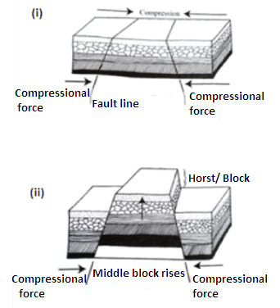

* The sinking middle block forms the floor of the rift valley while the raised blocks from the fault scarps which slope down wards from the top of the mountain.

**Scoring**

**Level 1**

Scores (1-3) if the response presents 1-2 steps which lead to the formation of Block Mountains with no illustrations and with a limited range of technical terms used appropriately

**Level 2**

Scores (4-6) if the response presents 3-4 steps which lead to the formation of Block Mountains with some illustrations and with a few technical terms used appropriately

**Level 3**

Scores (7-8) if the response presents 5-6 steps which lead to the formation of Block Mountains well explained, illustrated and with a good range of technical terms used appropriately

(**max=8marks**)

1. Adam and his family live on one of the slopes of a block mountain in Kenya. Explain the likely problems faced by Adam’s family as a result of living in such an area.

**Possible responses:**

* Landslides especially during heavy rains which these destroy life and property.
* Frequent occurrence of soil erosion due to steepness of land /difficulty in preserving soil fertility.
* Attacks from wild animals which destroy crop gardens especially if the mountain is forested.
* Mountain slopes have thin/skeletal soils which limit agriculture.
* Poor transport and communication due to the difficulty associated with construction of communication lines.
* Limited access to social services such as schools, medical facilities, recreation centres etc since the mountains are remote.
* Aridity; if the family lives on the lee ward side of the mountain
* Limited sources of surface water for domestic and farm use.

(**8marks)**

**Scoring**

**Level 1**

Scores (1-3) if the response merely lists 1-4 relevant ideas relating to living in a mountainous area

**Level 2**

Scores (4-6) if the response 4 relevant ideas with two well explained and the others just mentioned with a limited range of technical terms used appropriately

**Level 3**

Scores (7-8) if the response 4 relevant ideas well explained with a good range of technical terms used appropriately

**8marks**